Task undertaken: | Container Stack Heights | Date: | 29 June 2021
Location: | Tyne CS - MT Movements -Gate B54 Port Botany NSW
JSEA conducted by:
Assessment undertaken: - Risk Assessment or - Safe Work Method Statement

POTENTIAL HAZARDS |  |  |  |  |  |  |  |  |  |  |  | PERMITS/ CHECKLISTS
Health and Safety |  |  |  |  |  |  |  | Environmental
 | Biological |  | Hot Work |  | Remote/isolated work |  | UV exposure |  | Air Emissions |  | Hazardous Chemicals |  | Confined Space
 | Confined Space |  | Ladders |  | Repetitive actions |  | Work at heights |  | Asbestos |  | Hazardous waste |  | Hot Work
 | Electrical hazards |  | Manual Tasks |  | Slippery surfaces |  | Working with/near crane |  | Breach of Licence |  | Leachate |  | Manual Tasks
 | Ergonomics |  | Noise |  | Suspended loads |  | Working with / near plant |  | Dust |  | Odour |  | Permit to Work
 | Excavation |  | Non skilled worker |  | Temperature extremes |  | High Wind |  | Explosion – dust/fines |  | Radioactive waste
 | Fatigue |  | Plant – moving parts |  | Traffic Management |  | Falling Containers |  | Gas |  | Release to storm water
 | Flammable materials |  | Reduced visibility |  | Trip Hazards |  |  |  | Groundwater Contamination

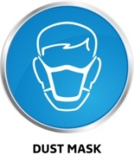 |  |  | 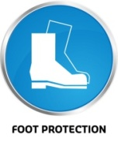 |  | 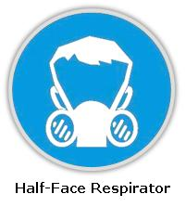 | 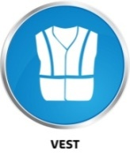 |  | 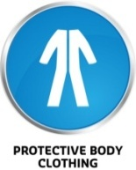 | 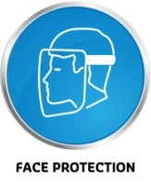 | Other:  (please specify)

PLANT & EQUIPMENT USED DURING TASK | Current WI / MAN available | LIST OF CHEMICALS USED DURING TASK | Current SDS available
Empty Container Handler - Forklift |  | N/A
SOP 1, 4 and 5

RISK IDENTIFICATION
Steps  Task & Environment Assessed | Safety / Environmental Risk and Hazards | Inherent  Risk  Level | Control Measure’s implemented | Residual  Risk  Level | Person Responsible
Empty container stacking heights. | Hazard:  - Containers falling if they are not stacked correctly.  - High Wind Events.  Existing Risk Control:  - Wind monitor has been Installed.  - Siren installed for high wind events.  - Annual calibration on the wind monitor tower.  - Wind monitored in real time.  - When stacking containers on hard stand surfaces, ensure they are stacked no higher than as follows: -  - 40ft Containers – maximum of six - (7) containers high  - 20ft Containers – maximum of six - (7) containers high  - 40ft High Cube Containers – maximum of six - (6) containers high  - 20ft High Cube Containers – maximum of six - (6) containers high | High | - The current container stacking plan shows a maximum of 7 high, with pyramid stacking (from 2 high) on northern and southern boundaries. Stacks on the western boundary to be stacked at maximum of 5 high.  - The SOPs 1, 4 and 5 are in place.  - Ensure all employees are trained on SOP 1 Container Loading and Unloading, SOP 4 Empty Container Handler Operations and SOP 5 Weather Monitoring and Container Park Securement.  - Continue to monitor the weather conditions and lower the containers as required based on the severity of risk.  - Any stack “leans” to be restacked immediately.  - Lower stacks in high winds as per Wind SOP #5. Single stacks must always be made safe asap.  - Complete and record Last shift checks before closing and leaving the site. | Medium | Depot Manager.
Environmental  Amenity | Container stack height impacts the environmental amenity for nearby commercial sites users and residents. | High | Containers not to be stacked higher than the maximum container stack heights allowable. | Medium | Depot Manager
Environmental  Amenity | Traffic issues caused by site operations impact the amenity to nearby commercial site users and motorists. | High | Ensure all loading and unloading activities are undertaken wholly within the site boundary.  Ensure that all vehicles entering or exiting the site do so in a forward direction.  Actively manage the truck rank by physically directing the traffic on site. | Medium | Depot Manager

Risk Assessment Model
Risk Level | Description of consequence or impact | Consequence | Likelihood/Probability
 |  |  | Unlikely (1) | Possible (2) | Almost Certain (3)
Low  Level of harm | Incident that has the potential to cause persons to require first aid. Environmental discharge/release immediately contained, minor level clean-up with no short-term environmental harm. | Minor (1) | Low  (1) | Low  (2) | Medium  (3)
Medium  Level of harm | Actual/Potential temporary disability, MTI or LTI. Structural failure/damage, >1-day outage. On-site environmental discharge/release contained, minor remediation, short-term environmental harm. | Moderate (2) | Low  (2) | Medium  (4) | High  (6)
High  Level of harm | Actual/Potential fatality, disability or irreversible damage. Major structural failure/damage. Off-site environmental discharge/release not contained and significant long-term environmental harm. | Major (3) | Medium  (3) | High  (6) | High  (9)
Level | Likelihood/Probability
Almost Certain | Occurs frequently; >66% chance of occurring
Possible | Could happen occasionally; >33% but <66% chance of occurring
Unlikely | May occur only in exceptional circumstances; <33% chance of occurring
Class/Ranking | Description/Requirements
Low 1, 2 | Will require localised control measures.
Medium 3, 4 | Will require operational planning. Actions will be recorded on SWMS.
High 6, 9 | Stop immediately. Implement permanent Preventive controls. Will require detailed pre-planning. Actions will be recorded on a SWMS.

TRAINING, QUALIFICATION & LICENCES REQUIRED TO COMPLETE WORK
National Licence to Perform High Risk Work Class: - LF - Forklift
ADDITIONAL COMMENTS & REQUIREMENTS
Induction to SOP#s 1, 4 and 5

IDENTIFICATION OF TASK RISK MANAGEMENT AND REVIEW
 | Non -Routine Task - this task is a one-off occurrence
 | Routine Task - this task is undertaken on regular basis | Task / Risk and hazards identified must be included in the Site Risk Register

REVIEW
Date | Reviewed by | Relevant changes & modifications made to SWMS OR Risk Assessment
SIGN-OFF
Manager or Authorised Representative
Reviewed by Manager or Authorised Company Representative:

On review of the information supplied in this form the work is authorised to proceed

Name: _______Rohen Drury_______________________________________________ Signature:__________________________________________ Date:________________________

Name: _______Aaron Powell ____________________________________________ Signature:__________________________________________ Date:________________________

SIGN-OFF
Worker
By Signing below you agree that you have READ and UNDERSTOOD this SWMS and the hazards and risks relevant to this task and AGREE TO COMPLY with all controls identified.
Full Name (Please PRINT name clearly) |  |  | Signature | Date

